Installation Procedures
1999-2005 Ferrari 360 Modena,
Spider & Challenge Stradale
SNS 121

Notice: Parking stops, high curbs, speed bumps, potholes, steep driveways, and other road abnormalities can cause damage to your STO N SHO and vehicle. STO N SHO LLC is not responsible for any damages that may occur to the STO N SHO bracket or vehicle itself due to improper installation, road conditions, driving, or care. Warranty only covers manufacture defects and STO N SHO LLC is not responsible for damages as a result of driving your vehicle.
Warning: Please read directions completely before starting. If you have any questions, please contact STO N SHO LLC before beginning your installation.
Parts Included: License Plate mounting bracket Assembly. Includes Base Plate and License Plate Holder
License Plate Mounting Screws: (2) 6mm X 10mm (Phillips head), (2) 6mm Acorn nuts (10mm wrench size)
Base plate mounting screws: (3) 6mm X 30mm bolts, (3) washers and (3) 3/8” spacers
Tools Needed: 10mm socket with ratchet Note: 1/4-inch drive preferred but 3/8 will work but extra caution will be needed when tightening bolts
Phillips screwdriver, and 10mm wrench
Step 1: Ensure all parts listed above are accounted for. Note: If at any time during the installation process you need assistance please call (408) 776-4080.
Step 2: Separate the license plate holder from the base by simply pulling the pull pin ring outward and sliding apart.
Step 3: Remove the three factory screws as shown in figure 1. Position the base mount with the pull pin on the right side as you are looking at the vehicle and line up to three holes where the two factory screws were just removed. See figure 1.
Step 4: Using the three 6mm X 30mm bolts secure the base plate to the vehicle. See figure 1.
Step 5: Secure the license plate and frame (optional) to the license plate bracket using the screws and nuts provided. Requires the Phillips screwdriver and 10mm wrench (Not included).
Step 6: Slide the license plate rods into the two tubes located on the base plate. Slide the rods into the tubes until the rods hit the pull pin. Simply pull the ring on the pull pin and advance the rods. Release ring and continue to advance rods until the pull pin locks into place. NOTE: The rods and spring-loaded pull pin are required to be sprayed periodically with WD-40 or any other silicone type spray lube. Failure to do so could result in either the failure of the pull pin or the rods becoming difficult to remove or reinsert. Note: In harsh environments, such as areas where roads are either salted or sanded in the winter, spraying of the rods and pull pin should be performed on a regular basis. Failure to provide this maintenance may void your warranty. See figure 2. On some occasions the license plate may require a little adjustment to level. Simply pull pin and slide plate out approximately two inches, grab frame at arrows (See figure 3) and rotate. If plate is high on left or right side, rotate high side down slightly and release. Verify alignment and repeat as necessary. Once leveled plate will remain level.
Congratulations! You have just installed the STO N SHOTM (Patented) front license plate mounting system. Thank You for your purchase.
Caution: Bracket lowers ground clearance by approx. 1/2 inch
Remove prior to entering automated car wash
Exercise care when entering or exiting steep driveways or damage will occur
Parking Stops or high curbs, stop well before or damage will occur
Remove prior to running on track or racing
If unsure, have bracket installed by your local Dealer or Body shop.
Warranty only covers manufacture defects and STO N SHO LLC is not responsible for damages as a result of driving your vehicle. Exercise caution and avoid roadways that will cause damage to your vehicle.
Limited Lifetime Warranty (Excluding Pull-pin). Pull pin will be warrantied for a period of 1 year (12 months) from the date of purchase.
STO N SHO LLC warrants to the original purchaser only that this product will be free of manufacturing defects in material and workmanship for the life of the product (Excluding pull-pin, see above) provided all maintenance is performed as required to the limitations and exclusions set forth below:
Return product to any authorized dealer. Contact STO N SHO LLC for the dealer nearest you. Upon examination, STO N SHO LLC or its representative will, at its sole option and expense, repair or replace any product found to be defective. If product to be replaced via mail, STO N SHO LLC will return the repaired or replaced unit to you via its usual shipping method from the factory to your address in the United States of America or Canada only. Any shipping costs for addresses outside of the United States or Canada shall be the responsibility of the purchaser.
This warranty is not transferable.
REMEDIES FOR BREACH OF WARRANTY.
This Warranty does not include repair for damage caused by improper use or handling, including but not limited to damage caused by accident, mishandling, improper installation, abuse, negligence, or any defect caused by repair to the product by anyone other than STO N SHO LLC.
This warranty does not cover reimbursement for your costs of removing and transporting the product for warranty service evaluation, or installation of any replacement product provided under this warranty.
This Warranty will be void if the product was not purchased from an authorized dealer or reseller.
THE FOREGOING WARRANTIES ARE EXCLUSIVE AND IN LIEU OF ALL OTHER EXPRESSED AND IMPLIED WARRANTIES. ALL SUCH OTHER WARRANTIES, INCLUDING BUT NOT LIMITED TO IMPLIED WARRANTIES OF MERCHANTABILITY, FITNESS FOR A PARTICULAR PURPOSE AND NON-INFRINGEMENT, WITH RESPECT TO THE PRODUCT. TO THE MAXIMUM EXTENT PERMITTED BY LAW, STO N SHO LLC SHALL NOT BE RESPONSIBLE FOR ANY INCIDENTAL OR CONSEQUENTIAL DAMAGES EXCEPT TO THE EXTENT PROVIDED (OR PROHIBITED) BY APPLICABLE LAW, EVEN IF STO N SHO LLC HAS BEEN ADVISED OF THE POSSIBILITY OF SUCH DAMAGES.
Notwithstanding the above, if you qualify as a “consumer” under the Magnuson-Moss Warranty Act, or applicable state laws, then you may be entitled to any implied warranties allowed by law for the Warranty Period. Further, some states do not allow limitations on how long an implied warranty lasts or allow the exclusion or limitation of consequential damages, so such limitations may not apply to you. This warranty gives you specific legal rights, and you may also have other rights which vary from state to state.
For the name of your nearest authorized STO N SHO dealer, contact: STO N SHO LLC at (408) 776-4080 or go to www.stonsho.com
Fig 1 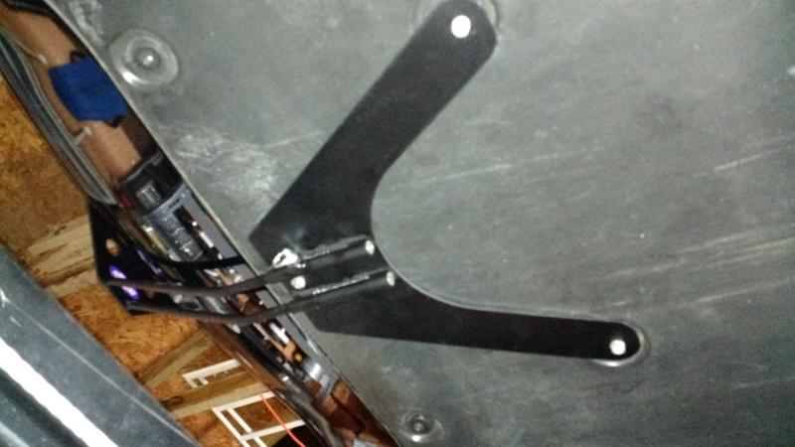
Fig 2
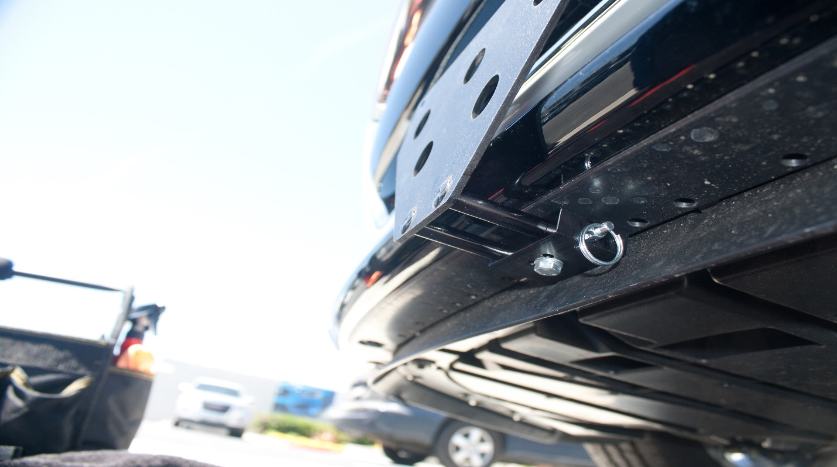

Fig 3

